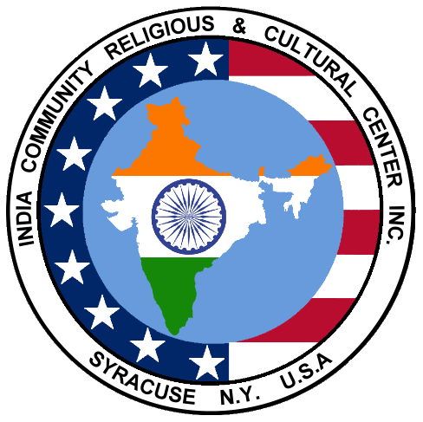
INDIA COMMUNITY RELIGIOUS &
CULTURAL CENTER, INC. (ICRCC)
A non-profit organization founded in1984

P.O. BOX 387 DEWITT, NY 13214
http://www.icrcc.org
http://www.facebook.com/ICRCC
Email: icrcc17@gmail.com

January-February 2017 Newsletter

What’s in this issue?

- ICRCC Board Members and Responsibilities
- Message from the ICRCC President
- Hello from the Newsletter Editor
- Membership Request
- Graduation Information Request; Events of Interest
- Ice Skating Event Information
- Calendar of Indian Festivals for 2017
- Sankranthi: Welcoming Warmer Days
- Community News: Remembering Satish Prasad
- Food Bank of CNY
- Celebrating Diversity at J-D School

Upcoming Event Summary
When | What | Where | Who (Coordinator)
Feb.26, 12:45PM | Indoor Ice Skating | Cicero Twin Ice Arena, 5575 Meltzer Court, Cicero, NY 13039 | JoeKappil@gmail.com
TBD | Holi | TBD | Frvora@yahoo.com
May 13 | Spring Festival | Wellwood School, 700 S Manlius St, Fayetteville, NY 13066 | Frvora@yahoo.com
Aug. 13 | Picnic
Sep.29-30 & Oct.6-7 | Garba
Oct. 29 | Diwali | Holiday Inn, Liverpool
ICRCC Board Members (2017)
President: Joseph Kappil, joekappil@gmail.com, 315-395-6148
Vice-President: Kishor Kanabar, kishorkanabar@gmail.com, 315-492-6372
Secretary: Sapna Kollali, smkollal@hotmail.com
Treasurer: Pravin Gupta, pravin.gupta@verizon.net, 315-491-9271
Newsletter Editor: Chilukuri Mohan, mohan@syr.edu, 315-391-8516
Website & Cultural Program Coordinator: Ramana Adavikolanu, ramana@icrcc.org, 315-656-2829
Membership Coordinator: Shridevi Karikehalli, shridilip@hotmail.com
Pavithra Chigateri, pchigat@hotmail.com
Sanjeev Kumar, skumar@oswego.edu
Rama Mehrotra, ramamehrotra@yahoo.com, 315-446-9036
Amisha Patel, amisharick@gmail.com, 570-371-8133
Viraj Patel, vpatel@vmpmanagement.com
Deepal Shah, shahdeepalr@gmail.com, 215-375-4137
Abraham Thomas, abethomas101@yahoo.com, 315-468-3887
Falguni Vora, frvora@yahoo.com

Finance Committee: Pravin Gupta (Chairman), Chilukuri Mohan, Kishor Kanabar

Membership Committee: Shridevi Karikehalli (Coordinator), Joseph Kappil, Falguni Vora, Deepal Shah

Newcomers welcome Committee: Pavithra Chigateri, Abraham Thomas, Shridevi Karikehalli

Charity Drive: Chilukuri Mohan, Joseph Kappil

Student Recognition Program: Pavithra Chigateri, Sapna Kollali

Bylaw Review Committee: Sanjeev Kumar (Chairman), Sapna Kollali, Rama Mehrotra

Connect with us by email at icrcc17@gmail.com

Written materials can be mailed to:
ICRCC
P.O. Box 387
Dewitt, NY 13214

Message from the ICRCC President

Greetings to all our Indian community members!

I am very honored to have the opportunity to serve as the new ICRCC President. I also want to introduce others who will help to lead the ICRCC this year. The Vice President is Kishor Kanabar who served as Secretary and Board Member in the past. Sapna Kollali is the new Secretary, she was our Newsletter Editor. Pravin Gupta is continuing as the Treasurer.

I have had the great pleasure of meeting many of you over the years, and have been an ICRCC member since 1990, and served as Treasurer and Vice President. I have also served other community organizations in Syracuse and in India. My family and I have enjoyed being part of the Indian community in Syracuse.

We have an excellent team of Board of Directors with many great strengths, community service background, and skills. We will work to the best of our ability to serve ICRCC and our community. We have the following Subcommittees in place this year:
- Membership Committee led by Shridevi Karikehalli (Coordinator),
- New comer’s welcome Committee led by Abraham Thomas,
- Charity efforts led by: Chilukuri Mohan,
- Student Recognition Program led by Pavithra Chigateri & Sapna Kollali,
- By-laws Review Committee led by Sanjeev Kumar (Chairman),
- Finance Committee led by Pravin Gupta, and
- Newsletter edited by Chilukuri Mohan.

The recent Board meeting identified two priorities to strengthen the ICRCC Vision and Objectives: Continuing to organize the existing events, and Organizing new community activities. We are planning to celebrate Holi in March/April (Coordinator: Falguni Vora), and Spring Festival on May 13. (Coordinator: Falguni Vora, working with Ramana Adavikolanu and Pavithra Chigateri).

The Indian community has a colorful cultural diversity with our dance, music, festivals, traditions and other practices. Our community is very resourceful with many talents. We need your support to organize various events: please help our Coordinators in making our events successful, and propose new events that you would like to lead.

ICRCC offer a stage for presenting, developing and sharing many talents and strengthening our community for the future. Please join the Indian Community in Central New York with your Support, Participation and Involvement.

Sincerely,
Joseph Kappil
joekappil@gmail.com
President

Hello (again) from the new editor
-Chilukuri K. Mohan

When I first came to Syracuse in 1988, I was fortunate to have a colleague who invited me to join ICRCC. I’ve enjoyed coming to know many community members over the years, especially during the years when I had served on the Board as newsletter editor during 1999-2000, and managed to stay a member even during the years when my attendance in ICRCC events had slacked off for various reasons. Remaining a member (even during the slack years) was like having a security blanket, a community to which I belong, well worth the membership fee—the dollar amount is comparable to what we spend if we go to a movie or a restaurant for dinner, things that have much less value over time than staying a part of the community.
Now I’m back doing something I like: writing, and compiling newsletter contributions from others. A newsletter need not be a bore: it can inform, enlighten, amuse, and provoke actions (or at least more words). Each of us has something to write that would be appreciated by other community members: perhaps a reminiscence, a travelogue, a story, an experience, an activity report, a poem, an event, healthcare advice, a perspective, or a thoughtful essay that conveys how we see the world. Please let us know about new arrivals, departures, promotions, awards, graduations, achievements, mergers and acquisitions among family and friends. We welcome photographs and write-ups about recent community celebrations (e.g. Garba and Diwali events in 2016). Please let us know if you have a skill that you would like to impart to community members and children.
This has been a quarterly newsletter, and it would be great if it can become more frequent, if we receive enough material from y’all. I am counting on YOU to write and send me something for the next issue! Borrowing a few lines from the Urdu poet Faiz A. Faiz (translated by V. G. Kiernan): Speak, for your lips are free; Speak, your tongue is still yours, …, Speak, for truth is still alive—Speak, say whatever is to be said.

In this issue, we have an article from the new President (Joe Kappil, not someone else), notes from the membership committee, a report on an event in J-D school, an article on Sankranti, and one on the Food Bank, in addition to community event updates. Please visit www.icrcc.org for the latest news, e.g., about plans for a Holi celebration in March.

Please let me know your opinion about the altered newsletter format; the choice, with considerable empty space to facilitate reading, was guided by the fact that we no longer need to compress everything into a few pages, since we no longer physically (“snail”) mail the newsletter.

Best wishes for a year of great success and joy to all!

ICRCC Membership Information

There are many advantages to become an ICRCC (India Community Religious and Cultural Center) member!
- Become part of the established Indian community in Central New York.
- Discounted rates for most paid events
- Supporting your non-profit community organization.
- All our events are not self-supporting; our community benefits from your support.

If you are not yet a member, please pay online: http://www.icrcc.org/membership.html or send a check ($50/Family and $30/Single) to ICRCC, PO Box 387, Dewitt, NY 13214
If you have any questions, please contact the membership committee:
Shridevi Karikehalli (Coordinator): shridilip@hotmail.com
Joseph Kappil joekappil@gmail.com
Falguni Vora frvora@yahoo.com
Deepal Shah shahdeepalr@gmail.com

ICRCC Permanent Membership:
If you are currently a member of ICRCC then please consider becoming a permanent member. It is your legacy in Central New York where you contributed to your professional field. This is the area your children grew up. This is the area where your friends are, where you dedicated numerous hours of your life for this organization as it grew and became established. Your continuous dedication is valued very much by the community!

Permanent members will have the same rights and privileges as the general members of ICRCC except that they will be recorded as permanent members for the life. Please view the website for more information: http://www.icrcc.org/permanentmembers.html

Membership fees for the permanent category are as follows: Family Membership: $1000. Single Person: $750. Please make check payable to ICRCC and mail to: ICRCC, PO Box 387, Dewitt, NY 13214. Also, you have the option to pay online. http://www.icrcc.org/membership.html

Tax Deductible: ICRCC is a Not-for-Profit Corporation under Section 501(c) (3) of the Internal Revenue Code. Your contribution to the Permanent Member Fund may be tax deductible. Kindly check with your tax advisor.

Graduation

Is your son or daughter graduating from high school this year? We want to know!

ICRCC will be recognizing area 2017 high school graduates during this year's Spring Festival in May. This is a voluntary program. If you would like to have your child recognized, please send an email to smkollal@hotmail.com or
pchigat@hotmail.com with the following information:
- Child's name, age, high school
- Parent's name(s), town of residence
- Child's future plans (college, job, military, travel)
- A brief synopsis of child's achievements (academic honors, sports, extracurriculuars).
Please note that program organizers reserve the right to edit child's achievement list for length.

Events of interest:

Feb. 7: Jhumpa Lahiri lecture
The acclaimed author will be speaking at 7:30PM at Hendrix Chapel in Syracuse University, as part of the University Lectures series. This is a free event open to the public; reduced parking available in the Irving Garage.

Feb. 16: Social Security Seminar (submitted by Sanjeev Kumar)
A Social Security seminar/dinner is being held by Deepal Shah and Sanjeev Kumar on February 16th. Any members who are interested may RSVP with Deepal Shah (315-350-2478) or Sanjeev Kumar (315-350-2510).

- Feb. 26: SPICMACAY Local Talent Show Spring 2017
SPIC MACAY @SU will be holding its Spring Local Talent Showcase on Sunday February 26th, 2017 in Slocum Hall Auditorium from 3:30-5:30. Please contact the organizers at spicmacay.su@gmail.com, or visit https://www.facebook.com/events/1247003265419869/

Indoor Ice Skating Event

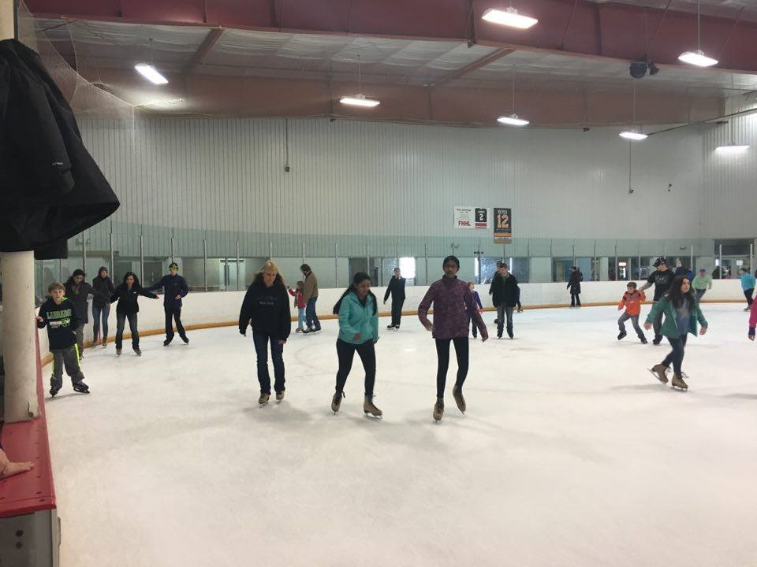
ICRCC is organizing an indoor Ice-Skating program during this winter season.
No prior experience is necessary; our volunteers will help you to start.
An adult presence is required. Children age 3+ and adults are welcome.

Date: Sunday, February 26, 2017, 1.00-3.00PM. (Arrive 15 minutes early)
Cost $4.50/person, including skate rental.

Location: Cicero Twin Ice Arena, 5575 Meltzer Court, Cicero, NY 13039

Contact
Joseph Kappil: joekappil@gmail.com, 315-395-6148
Sapna Kollali : smkollal@hotmail.com
Deepal Shah: shahdeepalr@gmail.com
.
Please confirm your attendance

Direction: From Syracuse: 81 North to Exit 30 to Rt 31 and turn left .2 miles, then right onto Brewerton Rd 1.1 mile, then turn left onto Meltzer Ct., facility on the right side. https://www.ciceroicerink.com

2017 Indian Festival Calendar
Date in 2017 | Festivals celebrated in India
January 14 | Sankranti/Pongal/Makara Sankramanam
January 26 | Republic Day
February 24 | MahaShivaRatri
March 13 | Holi
March 20 | Navroze (Parsi New Year)
March 28 | Ugadi/Yugadi (Telugu New year)
April 5 | Ramanavami
April 9 | Mahavir Jayanti
April 14 | Tamil New Year, Bengali New Year, Baisakhi/Vaishakhi/Vishu, Good Friday
April 16 | Easter Sunday
June 25 | Id-ul-fitr
July 9 | Guru Purnima/Vyasa Purnima
July 27 | Nag Panchami
August 4 | Vara Lakshmi Vratam
August 7 | Rakhi/Raksha Bandhan
August 14 | Krishna Janmashtami
August 15 | Indian Independence Day
August 25 | Ganesh Chaturthi/Vinayaka Chaviti
September 1 | Id-ul-juha
September 4 | Onam
September 21-29 | Navaratri
September 30 | Vijaya Dashami (Last day of Dasara/Dassehra)
October 2 | Gandhi Jayanti
October 8 | Karva Chauth
October 17 | Dhan Teras
October 19 | Diwali/Deepavali
November 4 | Guru Nanak Birthday
December 2 | Milad-un-nabi
December 25 | Christmas

Sankranthi: Welcoming Warmer Days
(Submitted by Shweta Karikehalli)

Whether you know it as Pongal, Uttarayan, Suggi Habba, or Sankranthi, this festival is one that holds a special place for all Hindus. Sankranthi is a significant holiday because it marks the end of winter; each day after Sankranthi, the days will gradually become longer "by the size of a sesame seed". Sankranthi falls on the 14th of January, which is unique because it is one of the only Hindu holidays with a fixed date; most other Hindu holidays follow the lunar calendar. It is also a special time for family and friends to gather, enjoy each other’s company, eat delicious food, and celebrate peace and prosperity.

In accordance with the abundance of names this celebration is known by, each region in India celebrates Sankranthi in its own unique way. My mother grew up in Maharashtra and says her favorite memories of Sankranthi are of her mother distributing Haldi Kumkum to ladies, eating a mixture of jaggery and sesame seeds called 'tilgul', dressing up with her family, and the interesting observation that women wear black saris. This is unusual because the color black is generally considered inauspicious and is not typically worn to poojas.

She also spoke of the importance of distributing tilgul as a gesture of kindness. “When I was growing up in Maharashtra, we would say 'Tilgul ghya godbola. In Karnataka it would be 'yellu bella thindu, olle maathadi.' Both these sentences translate into, ‘Just like this sweet mixture of jaggery, let's also be sweet to each other.’ Eating the tilgul also helps keep oneself warm in the cold months of winter, as the sesame seeds generate heat within the body.”

I spoke to my aunt, who grew up in Andhra Pradesh, about her experiences celebrating the holiday. “Andhra is more of a farming state, and Sankranthi falls around the time of the harvest. On the first day, called Bhogi, there are bonfires in the morning and everyone gets dressed up, and of course there is good food. The next day is Makara Sankranthi, in which all the married ladies go from house to house, distributing Haldi Kumkum, betel leaves, date fruits, and bananas. The main sweet made for Sankranthi is sweet pongal. Then the next day, called Kanuma, they decorate the cattle and do pooja for them since they are crucial for farming. All in all, it is a very joyous celebration, an exuberance of life.”

No matter where one comes from, Sankranthi is a time for happiness, celebration of the arrival of warmer days, and thankfulness for the bonds of family.

Remembering Satish Prasad
Our community lost one of its cherished members, Satish Chandra Prasad, on January 18, 2017.
Satish had a Ph.D. in High Energy Physics from the University of Massachusetts, and had been on the faculty of SUNY Upstate Medical University in the Radiation Oncology department since 1981, until he retired as a full Professor in 2010; he had also authored a widely read book on this topic, Review of Radiation Oncology Physics, and was a Fellow of the American Association of Physicists in Medicine and a Diplomat of the American College of Radiology.
Satish and his family have been active members of ICRCC for over thirty years. He had served on our Board, in addition to volunteering to make many community activities possible. He was a good friend to many of us, with his unforgettable humor, wit and brilliance. He has been a deep thinker, and explained his philosophy in a recently authored book, titled On Human Dilemma, written from a physicist’s perspective.
Satish was only 72 when he passed away. A memorial ceremony was held on January 22, 2017. Our heartfelt condolences to his wife Jayshri, daughters Monica, Anita, and Sunita, and their families.

The Food Bank of Central New York
(Submitted by Chilukuri K. Mohan)

Many of us seek to be involved in charitable or philanthropic activities and organizations. How can we maximize the good that we can do with our limited time and money? Can we perhaps help to address hunger, which affects one in seven individuals in this wealthy country? Can any organization claim that every contributed dollar reaches the intended final recipients, providing as many as three meals, with the least overhead compared to other non-profit organizations?

Perhaps the best kept secret is right in our area. The Food Bank of Central New York (FBCNY) has been helping to feed the hungry since 1985, providing 29,915 meals a day in Onondaga and surrounding counties, and constantly exploring new activities to help the hungry. I am fortunate to be serving on their Board of Directors, and have come to appreciate the wonderful dedication of those who lead and work at FBCNY.

The Food Bank is supported by individual donations as well as corporations, food producers, wholesalers and retail grocery stores, and the government (e.g., USDA’s Emergency Food Assistance Program). There is a large and well-maintained food storage facility and trucks periodically take food supplies to 250 partner organizations (food pantries, soup kitchens, and emergency shelters). Other not-for-profit agencies such as day care centers, rehabilitation centers, senior centers, and group homes also receive assistance to supplement their agency food needs.

A number of recent initiatives have focused on reaching hungry children, especially in rural parts of upstate NY, e.g., providing food in the summer to children when school lunches are not available. New Summer Food Service Programs, Mobile Food Pantry programs, and School Pantries have been recently initiated, along with food assistance to non-emergency programs such as day care centers and senior centers. FBCNY focuses on nutritious food (i.e., not junk) distribution and also works to educate recipients about the same.

FBCNY has the goal of providing an additional 3 million meals this year to food insecure individuals, developing new programs as needed. For those interested in donating, volunteering or visiting, the Food Bank of CNY is located at 7066 Interstate Island Road, Syracuse, NY 13209, (315) 437-1899 (website foodbankcny.org). Together, we can solve hunger!!

CELEBRATING DIVERSITY AT JAMESVILLE DEWITT ELEMENTARY SCHOOL
(submitted by Seema Sureshkumar)

India was very well represented as the JD Elementary School celebrated its first ever Multicultural Festival on January 19, 2017. Posters and artifacts displayed vignettes of Indian history, culture and cuisine. Gulab Jamoons and Samosas were also offered for the enjoyment of the attendees.
JD Elementary School students sang the Indian National Anthem. Attendees were asked to stand up for the National Anthem. The students had only a very short time to memorize and practice the song; yet they delivered an admirable performance. The program concluded with “It is a small world” song.

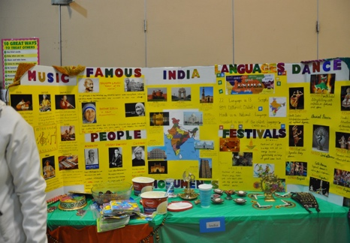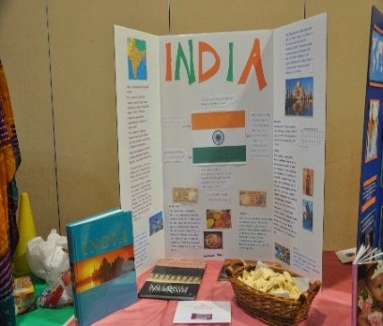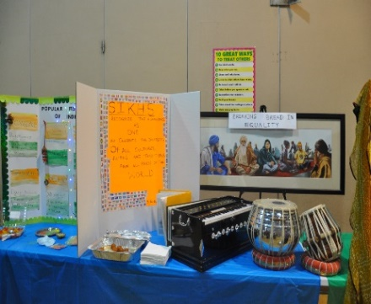

Kavya performed Indian Classical Dance called Kathak. The first part was invocation of God through a hymn which conveyed the message that Gurus are conduits to God, embodying the virtues of creators, preservers, and the universe itself. The dancer bowed to her Guru for guiding her on the path of knowledge and wisdom. During her performance, Kavya rendered many expressions (rasas), brisk spins and graceful hand movements.

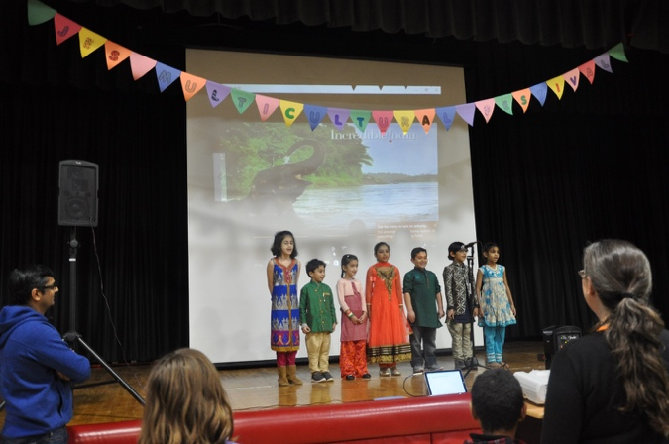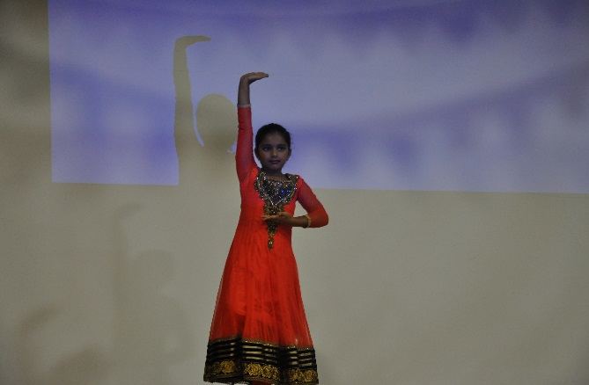

Participating children, shown above (left to right), included Aarushi Jagtap, Om Vaidya, Simran Sanders, Kavya Arasu, Devyansh Bhatt, Vivaan Shah, and Priya Pavoor. We ask our Indian Community Members to encourage our children’s schools to start celebrating diversity and hold Multicultural Festivals. India has lot to offer and we should showcase our culture with lot of pride, joy and humility.
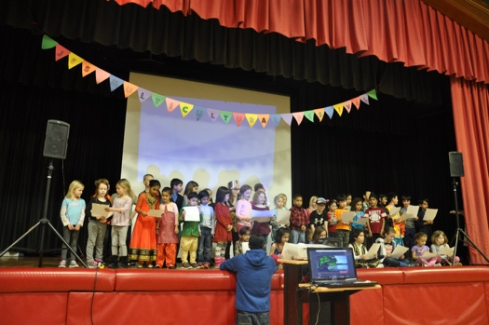

This is a list compiled from internet sources, please let us know of necessary corrections/additions. Some dates, based on the lunar calendar, may be off by a day due to geographical/astronomical errors.
The apparent discrepancy between the dates for Sankranti and the winter solstice (Dec.21) may be because of the annual change due to the axial precession of the earth. Pravin Gupta alerted us to the following quote from wikipedia.org: The actual position of winter solstice in the sidereal zodiac changes gradually due to the Axial precession of the Earth, shifting westwards by approximately 1 degree in every 72 years. Hence, if Makara Sankranti at some point of time did mark the actual date of winter solstice, it would have been so around 300 CE, the heyday of Indian mathematics and astronomy.

