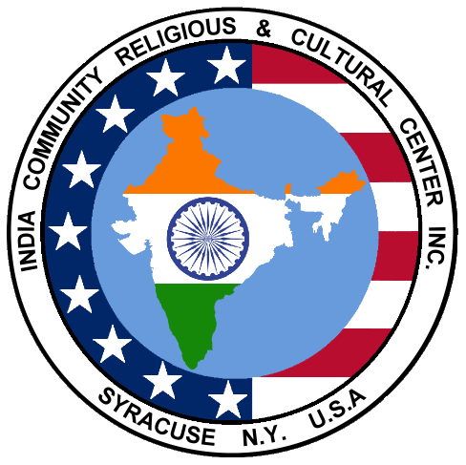
INDIA COMMUNITY RELIGIOUS &
CULTURAL CENTER, INC. (ICRCC)
A non-profit organization founded in1984

P.O. BOX 387 DEWITT, NY 13214
http://www.icrcc.org
http://www.facebook.com/ICRCC
Email: icrcc17@gmail.com

March 2017 Newsletter

What’s in this issue?
- ICRCC Board Members and Responsibilities
- Message from the ICRCC President
- Membership Request
- Permanent Member Profile: Jit and Manda Turakhia
- Permanent Member Profile: Neerja and Ajeet Gajra
- Graduation Information Request; Events of Interest
- Pictures from Ice Skating Event
- Living Options for Seniors
- Hands-On Volunteering
- MahaShivaRatri

Upcoming Event Summary
When | What | Where | Who (Coordinator) | Additional Notes
April 1, Saturday, 3PM | Holi   | Manlius Recreation Center, 6 Stickley Drive (near Fire Department building in Village of Manlius) | Frvora@yahoo.com | Free for members; $5/person for non-members; free for children under 12.
May 13, Saturday, 3PM | Spring Festival | Wellwood School, 700 S Manlius St, Fayetteville, NY 13066 | Frvora@yahoo.com | Canned food collection for Food Bank of CNY.
Aug. 13 | Picnic | Saw Mill Shelter at Onondaga Park, Liverpool, NY | sanjeev.kumar@prudential.com
Sep.29-30 & Oct.6-7 | Garba | CNY Indoor Soccer Stadium, 7201 Jones Road, Syracuse, NY 13209 | kishorkanabar@gmail.com | Entry fee $5 per person
Oct. 29 | Diwali | Holiday Inn, 441 Electronics Parkway, Liverpool
Information on events is listed on our website, at http://www.icrcc.org/culturalprograms.html

Please plan to attend and participate!

ICRCC Board Members (2017):
President: Joseph Kappil, joekappil@gmail.com, 315-395-6148
Vice-President: Kishor Kanabar, kishorkanabar@gmail.com, 315-492-6372
Secretary: Sapna Kollali, smkollal@hotmail.com
Treasurer: Pravin Gupta, pravin.gupta@verizon.net, 315-491-9271
Newsletter Editor: Chilukuri Mohan, mohan@syr.edu, 315-391-8516
Website Coordinator: Ramana Adavikolanu, ramana@icrcc.org,
315-656-2829
Membership Coordinator: Shridevi Karikehalli, shridilip@hotmail.com
Pavithra Chigateri, pchigat@hotmail.com
Sanjeev Kumar, skumar@oswego.edu
Rama Mehrotra, ramamehrotra@yahoo.com, 315-446-9036
Amisha Patel, amisharick@gmail.com, 570-371-8133
Viraj Patel, vpatel@vmpmanagement.com
Deepal Shah, shahdeepalr@gmail.com, 215-375-4137
Abraham Thomas, abethomas101@yahoo.com, 315-468-3887
Falguni Vora, frvora@yahoo.com

Finance Committee: Pravin Gupta (Chairman), Chilukuri Mohan, Kishor Kanabar

Membership Committee: Shridevi Karikehalli (Coordinator), Joseph Kappil, Falguni Vora, Deepal Shah

Newcomers welcome Committee: Pavithra Chigateri, Abraham Thomas, Shridevi Karikehalli

Charity Drive: Chilukuri Mohan, Joseph Kappil

Student Recognition Program: Pavithra Chigateri, Sapna Kollali

Bylaw Review Committee: Sanjeev Kumar (Chairman), Sapna Kollali, Rama Mehrotra

Connect with us by email at icrcc17@gmail.com

Written materials can be mailed to:
ICRCC
P.O. Box 387
Dewitt, NY 13214

Message from the ICRCC President

Dear Community Members,

We are about to welcome the refreshing and renewing Spring season in our Central New York. Springtime brings flowers and warmer weather conditions. We just organized a winter sport- an Ice Skating event on behalf of our community. We met a small group of new participants at the event.

Soon ICRCC will be celebrating Holi, a festival of colors. This will be followed by the Spring Festival, one of our most popular events, with cultural programs and varieties of food prepared. Children and adults have the opportunity to present their talents. Please contact the coordinators early.

ICRCC is a community organization. Most of us came here as immigrants from different parts of India with varying backgrounds. America is our new homeland, and we have second or third generation family members who are born here. We encourage you to involve and support our local community with whatever is possible. I believe our community is successful because of the opportunities available to us in America. This year, ICRCC is planning to work with local community support organizations, such as the Food Bank. I request each and every one of you to participate in these efforts with food donations or with generous cash donations.

The Indian Association (ICRCC) is established for our community participation and growth. Please become a member and support our events. We are providing forums for presenting and developing many of our talents. We are encouraging members and non-members to come for the events. Please participate, enjoy the events and meet new friends.

Thank you,
Joseph Kappil

Ice Skating. 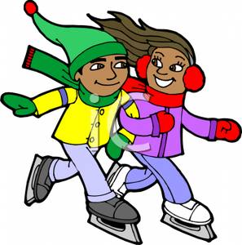
We just organized a winter sport, an Ice Skating event on February 26, 2017 at Cicero Twin Ice Arena, 5575 Meltzer Court, Cicero, NY 13039. We met a small group of new participants at the event. Thank you for all the participants and coordinators.

ICRCC Membership Information
Membership Update

We have added (5) more regular members recently, including one new permanent member family: Dr Seena and Dr. Manoj Kumar of Cortland, NY

Thank you for your Commitment and Trust!

List of Permanent Members

Anita and Dilip Bhole
Harinakshi and Ravi Dabir
Neerja Vajpayee and Ajeet Gajra
Shaila and Ramesh Gaonkar
Seena and Manoj Kumar
Damyanti and Satish Patel
Madhuri and Vilas Patil
Vijayalakshmi and Umeshchandra Patil
Ravi Raman
Neera and Ravi Seth
Madhuri and P.K. Sharma
Rajni and Praveen Simlote
Manda and Jit Turakhia

Become a Member!
If you are not yet a member, Please join us. Regular Membership is ($50/Family and $30/Single)
Permanent category is: Family Membership: $1000; Single Person: $750.
You may pay online: http://www.icrcc.org/membership.html or Mail a check to:
ICRCC, PO Box 387, Dewitt, NY 13214.

If you have any questions, please contact the membership committee:
Shridevi Karikehalli (Coordinator): shridilip@hotmail.com
Joseph Kappil joekappil@gmail.com
Falguni Vora frvora@yahoo.com
Deepal Shah shahdeepalr@gmail.com

Tax Deductible: ICRCC is a Not-for-Profit Corporation under Section 501(c) (3) of the Internal Revenue Code. Your contribution to the Permanent Member Fund may be tax deductible. Kindly check with your tax advisor.

Permanent Member Profiles: Jit and Manda Turakhia

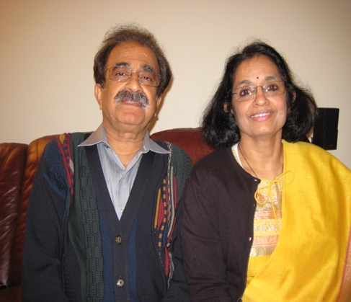

Jit is a very successful entrepreneur; he started his own company in Liverpool, J. T. Systems, Inc., in 1980. The company provides equipment to solve air pollution problems associated with manufacturing industries, the Department of Defense, and construction industries.

Manda is a homemaker and brought up their two children Tejal and Sujay. Tejal and her husband Rahul have their own financial company in San Francisco, and Sujay is a Building and Automation Engineer with Trane Co., in Norfolk, Virginia.

Jit and Manda both grew up in Baroda, Gujarat. Jit came here as a student to pursue his graduate work at Mississippi State University, after getting his mechanical and electrical engineering degrees from Gujarat University in India, and completed his master’s degree in electrical engineering in 1970. Manda came to USA to join Jit in Richmond, Virginia, and they moved to Syracuse in 1977.

Jit and Manda are both very active in various organizations. Jit was one of the founding members of ICRCC and served as a Vice President and a treasurer for several years in 1980s. He was also very active in JAINA, a national organization for members of the Jain Community in North America with approximately 100,000 members in nearly 75 Jain Centers; he was a treasurer of JAINA and a Chairman of the membership committee. He also served on the OCRRA (Onondaga County Recovery and Recycling Agency) Board for seven years. Manda actively participates in various charity organizations such as American Red Cross and World Community Service of JAINA. One of her notable activities is supplying groceries to many needy families in Baroda every year.

Permanent Member Profiles: Neerja Vajpayee and Ajeet Gajra

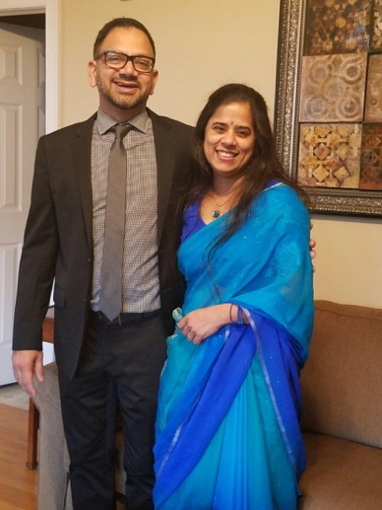

Neerja and Ajeet Gajra came to this country in late 90's. After completing their residencies and fellowships in this country they both joined Upstate Medical University as faculty members. Ajeet is currently the medical director of the Upstate cancer center and also a Professor in the division of Hematology-Oncology at Upstate Medical University. Neerja was an Associate Professor in the Department of Pathology at Upstate Medical up until 2016 where she was actively involved in medical student teaching besides diagnostic work. She now practices at Oneida Health care center, is a partner in Oneida Pathology Associates and the director of clinical pathology.

Neerja and Ajeet were born and brought up in New Delhi, both graduated from Maulana Azad Medical College in New Delhi and also completed their respective residencies in the same college. After getting married in 1996, they came to this country. They have two children, Ishan and Inika. Ishan is a senior in JD high school and Inika is in 8th grade at JD Middle School. Ishan will be graduating from high school this year and is headed for college.

Neerja served on the Board for three years from 2007-10. In early 2000, she along with her friends organized a group for our young children that met twice a month at the Hindu temple. The primary objective of the group was to expose our young children to Indian values, culture, and history. Later on, children were also involved in learning various languages such as Hindi, Gujarati, Telugu, and Nepali. During those years, children regularly participated in ICRCC Spring Festival; they have performed in various plays and dances every year.

Graduation

Is your son or daughter graduating from high school this year? We want to know!

ICRCC will be recognizing area 2017 high school graduates during this year's Spring Festival in May. This is a voluntary program. If you would like to have your child recognized, please send an email to smkollal@hotmail.com or
pchigat@hotmail.com with the following information:
- Child's name, age, high school
- Parent's name(s), town of residence
- Child's future plans (college, job, military, travel)
- A brief synopsis of child's achievements (academic honors, sports, extracurriculuars).
Please note that program organizers reserve the right to edit child's achievement list for length.

Events of Interest:

3/25 (Saturday), 7PM: Kathak dance recital by Labonee Mohanta, accompanied by Indradeep Ghosh on the violin, Jay Gandhi on the flute, and Indranil Mallick on the Tabla. Location; SUNY ESF Marshall Auditorium, organized by SPICMACAY, Syracuse (https://www.facebook.com/spicmacay.su/)

Living Options for Seniors
(Submitted by Ramesh Gaonkar)
Recently, several interested ICRCC members gathered at the home of Drs. Sabita & Kumar Ashutosh to discuss the needs and resources available in this area for those who are confronting some of the problems of aging. I presented a brief report on various senior residences and in-home programs coordinated through the Onondaga County/Office for Aging. Here is a brief summary.
Indian American Seniors have multiple options: 1. Living in your own home, 2. Living in your home assisted by children living nearby, 3. Living with your children, 4. Returning to India, 5. Living in a Senior community. Each option has its own issues. Below are some additional details on Living in Senior Community, and on Services Available if you are living in your own.​
Living in a Senior Community: The organizations that manage Senior Communities include two groups: Non-Profit and For Profit. There are three categories: a) Independent living, b) Assisted living, c) Skilled Nursing based on your health and ability to function. They offer two types of contracts: Lifetime vs. Fee-for-Services.

Lifetime Contract: CCRC - Continuing Care Retirement Communities are retirement communities with accommodations for independent living, assisted living, and skilled nursing care, offering residents a continuum of care. A person can spend the rest of his life in a CCRC, moving between levels of care as needed. One example is Kendal at Ithaca (http://kai.kendal.org)

Fee for Service Contracts include independent housing, residential amenities such as scheduled transportation and social activities, and access to a continuum of long term care services. The long-term care services, enriched housing/assisted living and skilled nursing facility care, are available on a fee for service or per diem basis. There is no long-term care benefit included in the contract; the resident pays for long-term care if and when needed. An example is Nottingham Senior Living, an independent living community in Jamesville, NY, designed for seniors who are able to care for themselves and wish to live independently, on yearly contracts. Two other examples of for-profit organizations are:
- RLC: a resort style community near North East Medical Center, Fayetteville, NY
- Anand Vihar: for Active Adults, in Tampa, Florida

Living in Your Home: Services available in Onondaga County: Services range from needs assessment, senior center activities, referrals for in-home caregiving, and assistance with transportation, meals and shopping. Support services such as transportation assistance and “Meals on Wheels” vary from one area (township) to another and fluctuate over time. Information and services are provided by the Onondaga County Department of Adult and Long Term Services, www.ongov.net/nyconnects; the best place to start may be a phone call to the line answered by Myrna Colgan, 315-435-2362, who has established a reputation for assessing caller needs and directing requests to the appropriate person. Residents of the Town of Dewitt (Dewitt, Jamesville, parts of Fayetteville) are recommended to start with the county site and then visit the website townofdewitt.com/seniors.aspx. Administrators stress the need for residents to inform themselves about these programs, however, before need arises or crises occur.

ICRCC may organize a seminar from community experts in this field. Please send a message indicating your interest in attending such a presentation to: icrcc17@gmail.com

Hands-On Volunteering
(Submitted by Anju Varshney)

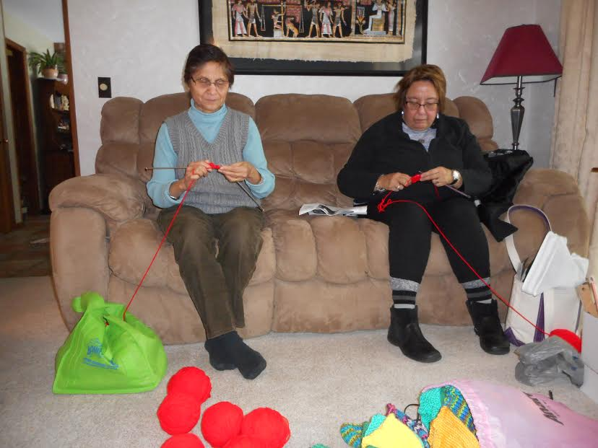

There are many opportunities to volunteer around us. Volunteering is not only satisfying but also makes an impact. By hands-on volunteering, I mean actually getting involved personally rather than only making donations for causes of your choice. In this article, I will describe some of the volunteering that I have done in the CNY community.

I volunteered at the Rescue Mission for several years. People there were very nice and appreciative and it was extremely gratifying to me. For the last few years, I have been volunteering at the zoo. Once again, it is extremely enjoyable. One may sign up to help with special events such as Halloween and Easter. It is a pleasure to see cute kids cheer up when they visit the zoo for special events!

Late last year, I started a hat knitters group which meets at my home once a month to knit hats for newborns. Current members of the group are Indra Balachandran, Vidya Goyal, Sonia Hartmann, Lakshmi Kavety, Rama Mehrotra, Sonia Otero, Jayashri Prasad and Rita Wali. We have already donated over a hundred hats to Crouse Hospital. If you are interested in joining the group, please contact me at anjuvar4972@gmail.com or (315) 637 4378. It is extremely fulfilling and rewarding to make an impact on the community and spend enjoyable time with friends or make new friends. I provide all the materials. I look forward to hearing from many of you.

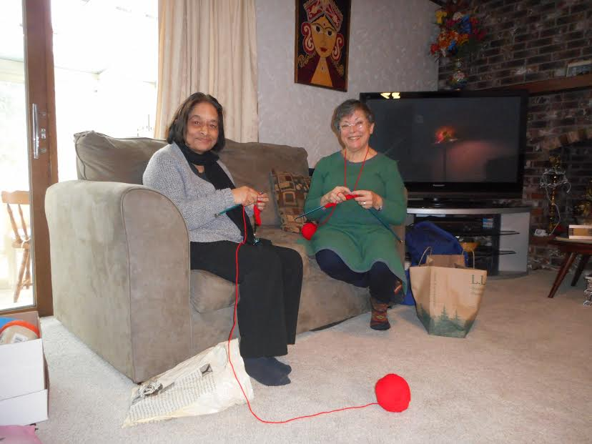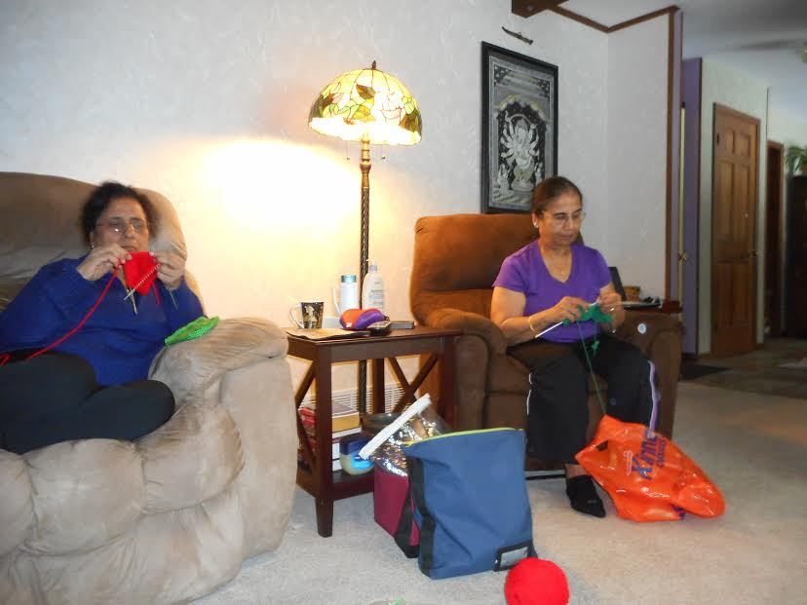
MahaShivaRatri
(Submitted by Chilukuri Mohan)

Our festival calendar this year had only one day marked in February: MahaShivaRatri was celebrated on Feb.24.

This day is an interesting example of how customs in different parts of India resemble and differ from each other. One story around this festival is that it celebrates the night on which Shiva (as Nataraja) dances, hence its importance for traditional Indian dancers. In Kashmir, this festival is celebrated as the wedding anniversary of Shiva and Parvati, celebrated by feasting, a sharp contrast from the way we celebrated the day in Hyderabad: we ``fasted’’—we would not eat rice or its usual accompaniments, but could snack on other things—those are my memories from the early seventies. Fasting went along with staying awake all night long, preferably singing bhajans and chants, minimally by attending midnight shows at the nearest movie theaters—invariably showing movies based on the epics or puraaNas, and often starring N. T. Ramarao as a blue-complexioned deity.

Shiva is worshipped in multiple ways today: ascetic, lord of death, lord of supernatural beings, destroyer of earthly desires, representative of human procreation, etc. But perhaps the most interesting is the story of how he prevented a virulent poison from engulfing the world, by holding the poison in his throat; his neck turned dark—hence the name “neela-kaNTha”. Here’s a critical lesson for leaders and rulers: save your constituents, sacrificing yourself if necessary. The principle of such self-sacrifice occurs elsewhere in Indian and other mythologies as well, beginning with the “Purusha” whose offering in the first Yajna results in the creation of the world.

Shiva is perhaps the oldest deity worshipped on the Indian subcontinent; artifacts that appear to represent Shiva were discovered even in the sparse archaeological finds found at Harappa and Mohenjodaro (c. 2500BC), in a yogic posture or as Pashupati (the lord of cattle, the most important wealth in ancient civilizations). In the Rigveda, the earliest written record of Shiva is as Rudra, he who eliminates sorrow ("rukh draavayathi")—other etymologies have also been suggested. In the Vedic and early post-Vedic literature, sometimes Rudra is identified with Purusha, and praised as the lord of the universe; in current tradition, Shiva is one of the trinity, with Brahma and Vishnu. Some sects exclusively worship Shiva, while most others consider Shiva as one aspect of Godhood, representing destruction. Although “Shankara” is considered one of the many names of Shiva, the traditions and schools established by Adi Shankara and his disciples are non-dualist, and say that no distinctions exist between various forms, human or other, setting the stage for total empathy with all living beings, and linked to the principles of non-violence that permeate various Indian schools of thought.

This is the first in a series of profiles of ICRCC Permanent Members.
Reference: Aging services: http://ongov.net/adult/documents/OfficeforAgingResourceGuideUpdatedJanuary12017.pdf
The Sanskrit word “neel(a)” (which meant “dark”) was probably reinterpreted to its other meaning as “blue” by early artists, explaining why so many Hindu calendars depict Shiva or Krishna as blue-complexioned.
An influential group of scholars argue for a cultural continuity on the Indian subcontinent dating from the Harappa era to the present, contradicting the traditional and long-held hypothesis that the current cultural milieu is the result of a later “Aryan” invasion from the west; an interesting work that argues for this idea is In Search of the Cradle of Civilization, Georg Feuerstein, Subhash Kak, David Frawley, Ill: Quest Books, (1995, 2001) ISBN 0-8356-0741-0.

